Author’s Writing Style

An author creates his/her writing style based on the types of literary devices and techniques they use within their writings. While you are reading your library book, look for different literary techniques and devices that the author uses (Literary Elements such as foreshadowing, flashback, suspense, conflict as well as elements of figurative language). In the format of a table, write the sentence (direct quote) from the book, which element is being used and give an explanation of what you think the author means by using this technique
Find five (5) quotes and five (5) different elements. Go to google docs and create a table that is similar to the example below (insert- table). Include the quote along with the page # from your book, the literary element being used and a clear explanation of what the author means by the use of this element. (purpose)
Direct Quote (pg #__) | Literary Element | Explanation
1.

2.

After you complete your chart, type a short paragraph summarizing the author’s writing style. Use your quotes, literary elements and explanations to help you conclude the style of the author. Share your chart and summary with your teacher.
Remember to include the correct heading:
Name, Date, Period #, English I
and create a title for your chart

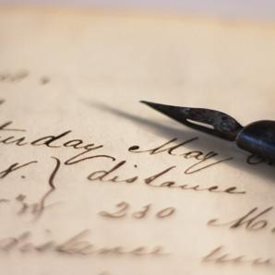
Author’s Writing Style

