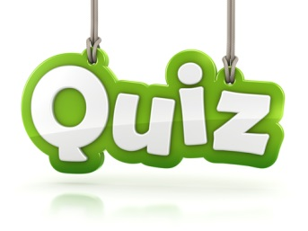
10 Question
After you have read your book, you are to create a 10 question multiple choice quiz. Make sure you include thought provoking questions not true/false. You will need to include questions about the story’s setting, characters, tone, mood, plot, theme and any other Literary Elements type of question. Your questions should not only be about the PLOT of the book. Go in depth; ask about why the characters chose to do something, or why the author wrote the events the way he/she did. ALSO you can use quotes from the book to ask about figurative language examples (See the Literary Elements/Figurative Language displays in the classroom)
- Give your quiz a title.
- The 10 question quiz must be typed. You will need to have 4 answer choices for each question (1 correct and 3 incorrect)
- You may only have a maximum of 3 PLOT questions: all others should be more in depth.
- Make sure you include an answer key as well as the quiz.

Make sure you put your correct heading:
Name, Date, Period, English I

Once you have completed your quiz you can email it to me at jconner@bremondisd.net

