Burgers  Candy Burger $8.97  A burger with seasonal seeds, covered with candy apple sauce, pork chops, and cranberry sauce  Donut bacon burger $10.00  A burger with donut buns filled with bacon, cheese, onions, and meat  Spaghetti burger $9.98  A burger from Italy, served with spaghetti buns, tomato sauce, and patty  Subway carbs (3 to 5 people required) $15.00  5 patties 5 cheeses covered in lettuce, pickles, onions, ketchup, and a long hoagie bun  Takis Burger (milk required) $12.00  If you like Takis then you will like a Takis burger, bacon, swiss cheese, patty, and black mushrooms for all spicy eaters | 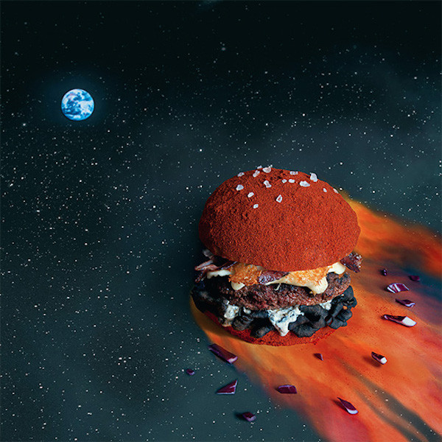  Crazy Patties  - Restaurant  123 Best Burger Alley  Dallas, TX  123-456-7890  www.crazypatties.org  Owners: Alonzo and JC  Cook: Gordon Ramsey
Appetizers  Appetizer Name 1 $00  It’s easy to print this menu two-sided for a professional finish. Just click the File tab and then click Print. Under the option that defaults to Print One Sided, select a two-sided print setting. Printer settings may vary.  Appetizer Name 2 $00  Appetizer description  Salads  Salad Name 1 $00  Salad description, as short or long as you like  Salad Name 2 $00  Salad description | Appetizers  Entrée Name 1 $00  Entrée description. This is the place to sell the dish. You know it’s brilliant—don’t be shy!  Entrée Name 2 $00  Entrée description

